Document - PayDirect Web Configuration Requirements
Version – 1.5
Maintenace Date – 2/28/13

PayDirect Web (Version 2014.1)
Configuration Requirements for City and County of San Francisco Arts Commission | Sales
Inflight

Implemented by Danaya Blanks
July-August, 2014

Table of Contents
Version History 3
Solution Overview 4
Inflight 4
PayDirect Configurations 5
User Parts and Line Items 11
Email Notifications 13
Client Approval 15
Appendix A 16
Label Configurations 16
Appendix B 23
Post Requirements 23
Appendix C 32
Postback Requirements 32
Configurable Options: 32
Notification for Failed Postback: 33

Version History
Version # | Date | Author / Editor | Version / Revision Comments
0.1 | 7/23/2014 | Danaya Blanks | Initial Draft based on Demo and Kickoff call.
0.2 | 8/6/2014 | Danaya Blanks | Updates per client call.
0.3 | 8/28/2014 | Danaya Blanks | Changes have been applied per client call.

Solution Overview
PayDirect Web is FIS’ standard Browser-based payment application. FIS provides five convenient and easy to use web flows to meet the needs of our customers. The standard PayDirect product is a standard application and is not intended to display a customer’s bill.
If a bill presentment page is required, this will be custom development. Please refer to the Sales Representative as FIS may charge for custom development.
FIS does not support PayDirect Web applications hosted inside html framing.

Inflight
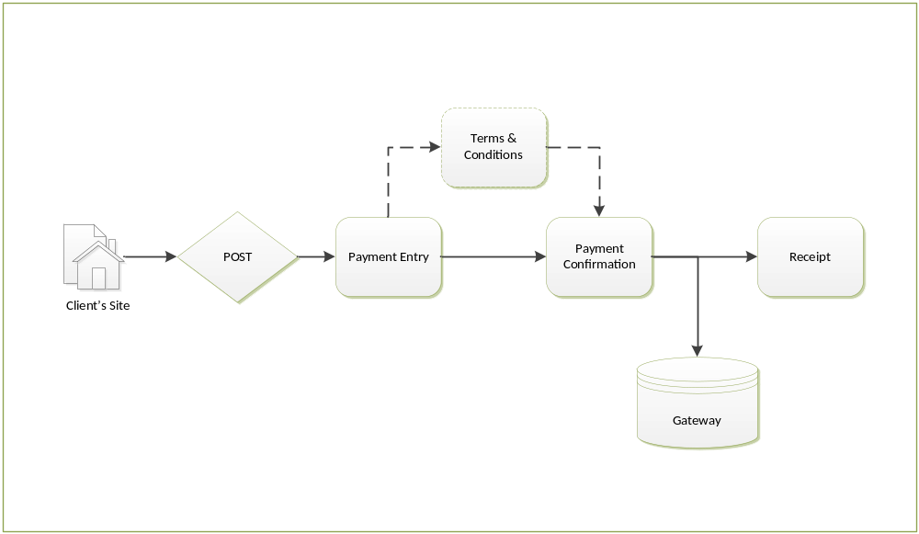

Please note: The terms and conditions page will appear immediately after the Payment Entry page if configured for use.
FIS’ In-Flight Payment Flow allows the Client to validate customers and present billing information on your existing website and then link customers to our secure website for the actual selection of desired items and/or entry of sensitive payment information. This payment flow works by providing a payment site that seamlessly integrates with the Client’s existing website(s), eliminating the need for the handle, transmit, or otherwise “touch” sensitive payment information. The Client validates customers through your systems, while payment information is collected by FIS. Through a unique identifier assigned by the Client, the balance of the customer’s account is passed through to the payment pages designed and maintained by FIS.
FIS will utilize Payment Entry, Payment Confirmation, and Receipt pages that can be configured to look and feel like the pages on the Client’s existing website, allowing customers to make payments confidently and securely. Customers appreciate this payment flow because they can make payments in three simple steps.

- Payment Entry Page. After the customer is validated at the Client’s website, he or she will access the payment page where payment information is keyed.

- Confirmation Page. Once the payment information is keyed, a confirmation page displays allowing the customer to make any necessary changes.
- Receipt Page. Upon submittal and authorization of the payment information, a printable receipt is provided with a confirmation number confirming the transaction.
Please review Form POST and POST Back requirements (Appendix A and B) before document completion.

PayDirect Configurations
The standard application allows for configurable default options. Below are the configurable default options. After the application is implemented into production, the client will need to submit a change request to FIS’ support team to update a configurable option.
- Client Name
City and County of San Francisco Arts Commission
- Project Name
SF Arts Commissions & Gallery Sales Inflight Web
- Unique Merchant Site Name
Unique name for the site/application (i.e. http://paydirect.link2gov.com/[unique site name])
SFACArtsSales
- Session Length (0 – 60 minutes)
Choose the session timeout window. Once the session timeout window is reached (i.e., the user doesn’t send or request any information to/from the application, such as by navigation from page to page), the information on the screen is lost and the user must start their payment from the beginning.
20 mins
- Workflow
FIS offers the following payment flow applications as described in the Overview section. Please choose one payment flow.
☐ Passthrough – Client must provide a Form Post to POST into the Payment Entry page.
☐ 2 page – User lands on Payment Entry
☐ 3 page – User lands on Data Display
☐ Allow Line Items to be selected – User can edit information posted into PayDirect
☒ Inflight Client must provide a Form Post to POST into the Payment Entry page.
☒ 3 page – User lands on Payment Entry
☐ 4 page – User lands on Data Display
☐ Allow Line Items to be selected – User can edit information posted into PayDirect
☐ Non-Validating (4 page) – Client must provide an End User Load File.
☐ Non-Validating / Manual Entry (4 page) – Customer will manually enter information into the application.
☐ Validating (5 page) – Client must provide an End User Load File.
- Post Type
If Passthrough or Inflight, the Post Type must be selected below.
Passthrough | Inbound | ☐ XML Post | ☐ HTTP Form Post
Passthrough | Outbound | ☐ XML Post | ☐ HTTP Form Post
Inflight | Inbound | ☐ XML Post | ☒ HTTP Form Post
- Date/Time Display
The date time displays on the Receipt page as the date and time the customer processed their payment
☒ 12 hour ☐ 24 hour
☐ 12 hour with seconds ☐ 24 hour with seconds

☒ Merchant Timestamp ☐ FIS Timestamp
- Allow Overseas Military Mail
Allows a user to choose “Armed Forces Americas (AA)”, “Armed Forces Europe (AE)”, or “Armed Forces Pacific (AP)” if overseas military from the Billing State dropdown menu during the payment process.
☒ Yes ☐ No
- Collect shipping address
User is required to enter a Shipping Address during the payment process. The Shipping Address may be the same as the Billing Address. If Shipping Address is enabled, User Part 6 will be overridden with Shipping Address.
☐ Yes ☒ No
- Allow International Address
This option allows a user to enter an International Address during the payment process. Not recommended if AVS is used due to data differences in international addresses.
☒ Yes ☐ No
- Determine Default State
By default, a state may be displayed in the Billing State drop down menu during the payment process.
☒ Yes Please list state: CA ☐ No
- Return URL (Successful Payment):
The Return URL is the location where the user will be directed if they choose to click the Finish button on the Receipt page after a successful payment.
CA Environment: http://www.sfartscommission.org/
Production Environment:
- Cancel URL
The Cancel URL is the location where the user will be directed if they choose to click Cancel payment during the application.
CA Environment: http://www.sfartscommission.org/
Production Environment:
- Merchant Codes:
The following merchant codes are associated with the specific application for Production.
Principle Merchant Code: 06SFR-ARTSC-SALE3-W
Principal Merchant Settle Code: 06SFR-ARTSC-SALE3-00
- Visa Tax programs should include the following (only applies to Visa Tax programs)
Convenience Fee Merchant Code:
Convenience Fee Merchant Settle Code:
- Convenience Fee Alias
If the application is Convenience Fee funded, by default the application will display a label, “Convenience Fee”. However, the Convenience Fee Alias allows a different label other than the default.
Enter Here ☒ Not Applicable
- Payment
The application may allow underpayment, overpayment, or only allow the user to pay the exact amount. If the user may pay under the amount due (restricted to credit transactions), please provide the minimum payment amount the user must pay. If the user may pay over the amount due, please provide the overpayment payment amount the user must pay.
  - Exact Amount
User must pay the exact amount due.
☒ Yes ☐ No ☐ Not Applicable
  - Underpayment
This allows the customer to enter a payment amount that is less than their amount due. Minimum payment amounts only apply to Agency Funded applications. Convenience fees may include a minimum fee.
☐ Yes ☐ No ☐ Not Applicable
  - Transaction Minimum (applies to credit transactions only)
Regulations mandate that if minimum are used the minimum cannot exceed $10.
$0.01 - $10
  - Overpayment Maximum
This sets a limit a user can pay over and above their current payment amount.
Enter over payment amount here. ☐ Not Applicable
  - Other Instructions
If Yes, please provide text here
- Line Item Quantity
If needed, a line quantity can be specified when line items are used. This field can be read-only or editable. Configurations for minimum and maximum quantity can also be set per-line item.
☐ Line Item Quantity | ☐ Entry Allowed | ☒ Not Applicable
- Card Number Entry
The user has the ability to enter the card number once (Single Entry) or twice (Double Entry), with the capability to mask the card number.
☒ Single Entry Requires the user to enter their Card Number once
☐ Double Entry Requires the user to enter their Card Number twice for validation
☐ Masked Will not display numbers to user. Instead a “*” will display per number entered.
☐ Not Applicable
- CVV Entry
The user may have the ability to enter their Card Verification Number located on the back of their card depending on setting(s) chosen below.
☒ Single Entry Requires the user to enter their CVV Number once
☐ Double Entry Requires the user to enter their CVV Number twice for validation
☒ Masked Will not display numbers to user. Instead a “*” will display per number entered.
☐ Hide The user will not have the ability to enter the CVV number in the application.
☐ Not Applicable
- Account Number Entry
If the application accepts E-Check, the user may enter the E-Check Account Number once (Single Entry) or twice (Double Entry), with the capability to mask the Account Number.
☐ Single Entry Requires the user to enter their personal account number once
☐ Double Entry Requires the user to enter their personal account number twice for validation
☐ Masked Will not display numbers to user. Instead a “*” will display per number entered.
☒ Not Applicable
- Routing Number Entry:
If the application accepts E-Check, the user may enter the E-Check Routing Number once (Single Entry) or twice (Double Entry), with the capability to mask the Routing Number.
☐ Single Entry Requires the user to enter their routing number once
☐ Double Entry Requires the user to enter their routing number twice for validation
☐ Masked Will not display numbers to user. Instead a “*” will display per number entered.
☒ Not Applicable
- Email Address:
  - Email Required
If email is required, the user is required to enter the address during the payment process. If eCheck payment is an option, eCheck payments will always require email based on NACHA rule 2.3.2.2 (b)
☒ Yes ☐ No
  - Double Entry
If email address double entry is required, the user is required to enter their email address twice for verification during the payment process.
☐ Yes ☒ No
- Telephone Number Required:
If telephone number is required, the user is required to enter the number during the payment process.
☐ Yes ☒ No
- Application Design:
Each page of the application will contain a header image, header text, and footer text as specified by the client. The standard header image size is 82 by 992 (W) pixels. If the header image is smaller than 992 pixels, the spacea small white space will display on either side of the header image. If the header image is wider than the advised width, a horizontal scrollbar will appear. If you implemented prior to release 2013.3 into production with a 80x960 header image, FIS resized the image automatically.
- Header Image
The image must be 82 by 992 pixels. Please see samples below:
- Header Text:
The header text is optional text that can be displayed under the header image. The Header Text accepts html.
☐ Yes ☒ No
If Yes, please provide text here
- Footer Text Enabled:
The Footer may be enabled (On), which allow the Footer Text to display or disabled (Off), which will not allow the Footer Text to display Footer Text: Footer text will display on all pages of the application The Footer accepts html.
☐ Yes ☒ No
If Yes, please provide text here
- Style Sheet (Not required):
There may be text alignment modifications, background appearance, or font modifications that may be updated in the style sheet. Please specify style sheet changes. Default Style Sheet below:

Default  body {  background-color: #DDDDDD;  }  .container {  background-color: #EEEEEE;  border-bottom: 2px solid Gray;  border-left: 2px solid Gray;  border-right: 2px solid Gray;  }  .box {  background-color: black;  border: 1px solid #EEEEEE;  padding: 10px;  }  .headerImage {  background-color: #DDDDDD;  background-repeat: no-repeat;  height: 80px;  position: relative;  width: 960px;  }  .footer {  padding-bottom: 10px;  padding-top: 10px;  text-align: center;  }  .field-validation-error {  color: Red;  display: block;  font-size: x-small;  font-weight: bold;  margin-top: -5px;  } | Production  body {  background-color: #444444;  .container {  background-color: #FFFFFF;  border-bottom: 0px solid Gray;  border-left: 0px solid Gray;  border-right: 0px solid Gray;  }

- Terms and Conditions:
The user must accept the Terms and Conditions prior to continuing to process a payment. The Terms and Conditions page is displayed prior to the Confirmation page. Terms and Conditions accepts html.
☐ Yes ☒ No
TBD
- POS (Point of Sale Swipe for Virtual Terminal applications):
This allows swipe device capability and accepts input from supported card readers. If POS is enabled, the Billing Information is not required to be entered by the user during the payment process.
If Swipe capability is enabled, the application cannot accept PIN-less debit as a payment type.
☒ Not Applicable Application will not support POS Swipe capability
☐ Support Swipe Allows users the ability to enter the card information or swipe a card with a supported card reader.
☐ Swipe is default entry method by default; user will be prompted to swipe a card in order to proceed. There is an option to cancel the swipe function and manually enter the card information.
☐ Display signature line on Receipt page This will provide a signature line on receipt page.
☐ Print two copies This will provide a second copy of the receipt page.
- Text Configurations
Specified Labels, Titles, Billing Information, and Shipping Information may be customized. Screenshots in Appendix A indicate labels available for configuration.
☐ Yes ☒ No
If Yes, Please provide text here:
Page | Location | Text

User Parts and Line Items

User Parts:
Field  Order | FIS Field Name | Display on site?  [Y/N/] | Description  Default | Entry Allowed  Default  [Y/N]  (Override current text) | Entry Required  Default  [Y/N]  (Only if Entry Allowed is selected) | Entry Minimum Length Default  (Only if Entry Allowed is selected) | Entry Maximum Length Default  (Only if Entry Allowed is selected)
1 | Shipping Address | N
2
3
4
5
6
Line Items:
Field  Order | FIS Field Name | Line Item Qty  [Y/N] | Entry Allowed  Default  [Y/N]  (Override current text) | Entry Required  Default  [Y/N]  (Only if Entry Allowed is selected) | Entry Minimum Length  Default  (Only if Entry Allowed is selected) | Entry Maximum Length  Default  (Only if Entry Allowed is selected) | Settle Code  [Y/N]
1 | Item
2 | Description
3 | Amount

User Parts and Line Item Display
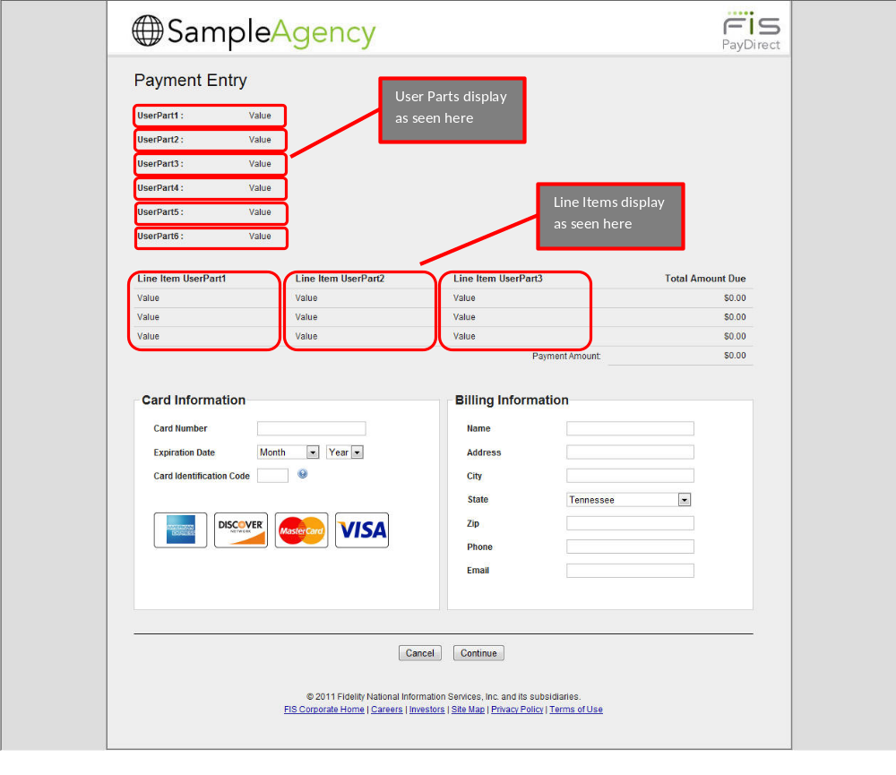

Email Notifications
A confirmation email should be sent to the user after their payment is successful as long as the user entered their correct email address. No Confirmation email will be sent if the user chose not to enter their email address. There may be multiple Recipients who receive an email upon completion of a successful transaction. For example, if the customer enters their email address during the payment process, they will receive a confirmation email. The client may also receive the same email that the customer received, but will not include the customer’s email address.
- Require Email Notification sent to the user
☒ Yes ☐ No
- Should a Confirmation Email be sent to the user upon processing of the payment?
☒ Yes If yes, please complete the sections below by email type and environment.
☐ No

Message  (This is the default Email Text, but may be modified.) | This e-mail will serve as confirmation that your payment was received.  The transaction information is listed below:  Confirmation Number: #TransactionID#>  Date and Time: #MerchantTransDateStamp# Displayed as MM/DD/CCYY HH:MM:SS  HH:MM:SS A.M./P.M.  Total Amount Paid: $XX.XX  PLEASE KEEP THIS FOR YOUR RECORDS.
Subject
(Limit 150 characters)
Sender  (Email and Postback) | noreply@link2gov.com (not configurable)
CA Duplicate Email Address

Prod Duplicate Email Address

- Email Message Variables:
The Email Message may include any of the following values, as well as additional text. Please check those that apply.
 | Email Address |  | Total Payment Amount |  | Billing Zip Code
 | Authorization Code |  | Account Holder Name |  | Billing Country
 | Transaction Code |  | Return Code |  | Billing Phone Number
 | Transaction Date Stamp |  | Return Message |  | User Part 1
 | Payment Amount |  | Payment Method Code |  | User Part 2
 | Convenience Fee 1 |  | Account Number Last Four |  | User Part 3
 | Convenience Fee 2 |  | Billing Address |  | User Part 4
 | Convenience Fee 3 |  | Billing City |  | User Part 5
 | Convenience Fee 4 |  | Billing State |  | User Part 6
- Email Retry Attempts
If the Confirmation Email fails to send the first time, FIS’s system will attempt to send the email every [number of seconds specified below], up to the number of times, as specified below.

Retry Attempts - If the confirmation email fails to send, FIS’ notification system will attempt to send the email [ 3 ] times.
Retry Delay – The Notification system will retry every [ 30 ] seconds between retry attempts.

Client Approval
This document has been approved as the PayDirect Configuration for the San Francisco Arts Commission’s Web application and accurately reflects the current understanding of project requirements.
Following approval of this document, requirements changes will be governed by the project’s change management process, including impact analysis and appropriate reviews and approvals.
Authorized Signature – San Francisco Arts Commission Date
Print Name

Authorized Signature – FIS Date
Print Name

Appendix A

Label Configurations

Data Query

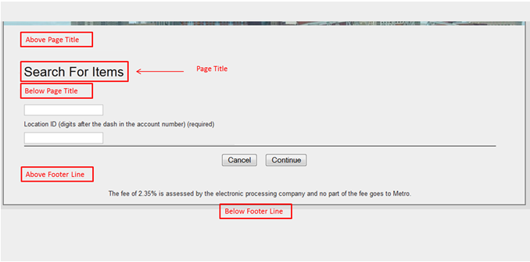
Error, Format and Item Not Found

Data Entry
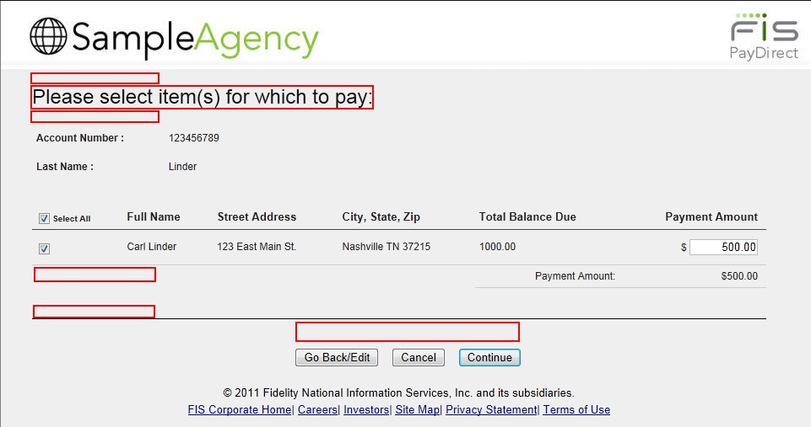

Payment Entry
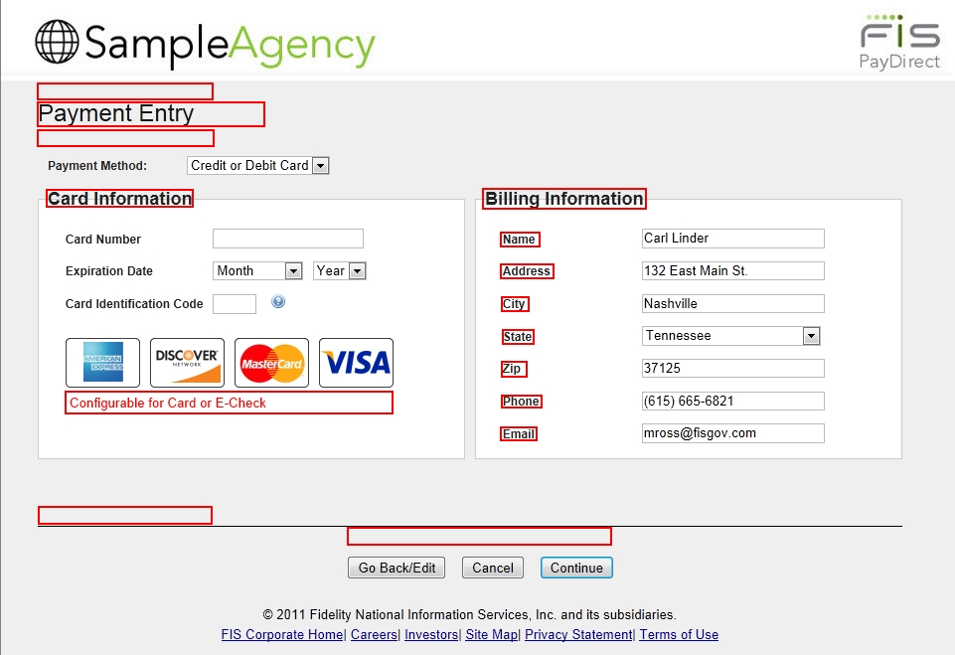

Terms and Conditions
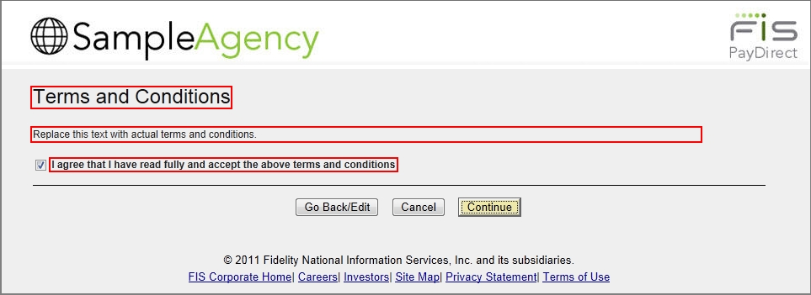

Payment Confirmation
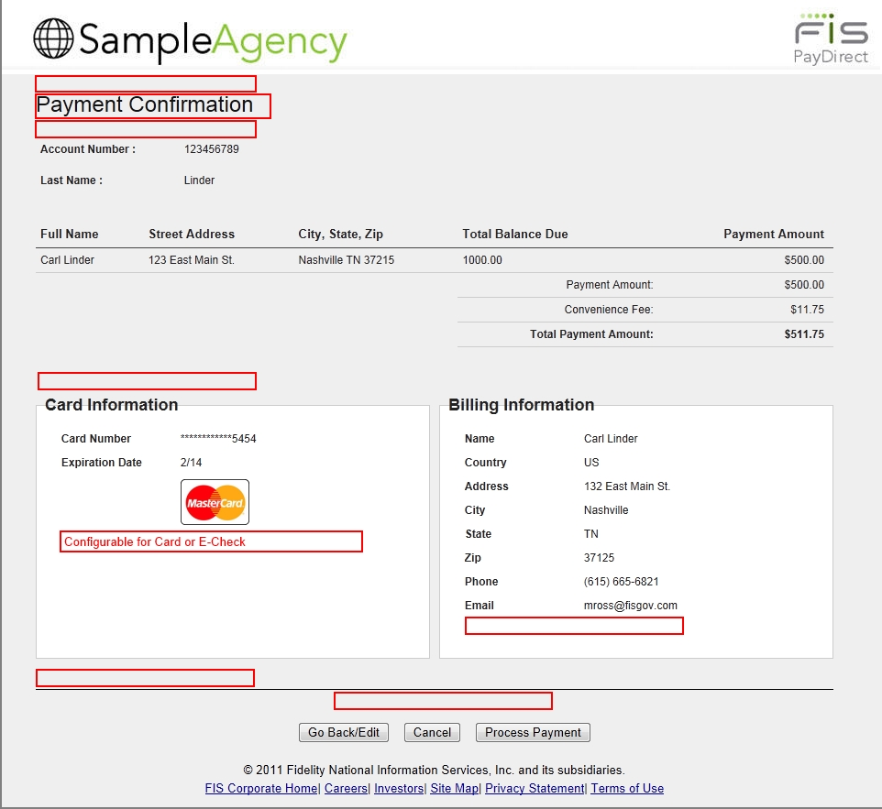

Card Receipt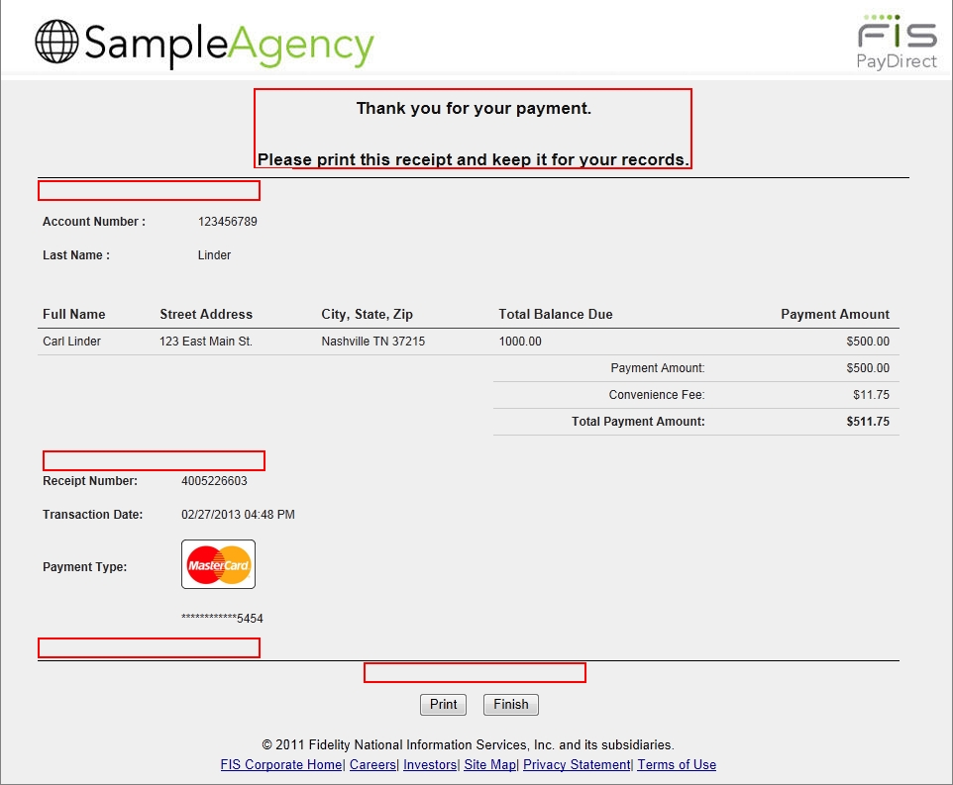

eCheck Receipt
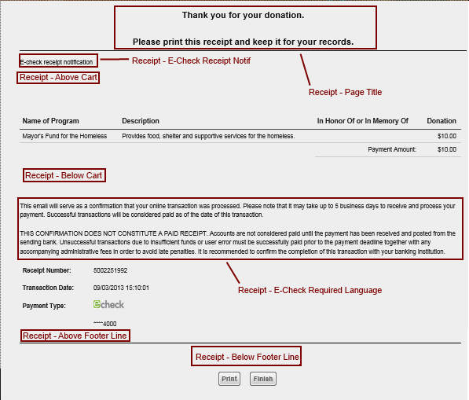

Appendix B

Post Requirements

FIS will accept an XML Post or HTTP Form Post into the Passthrough or InFlight applications. The application URL will be provided by FIS.

Post Fields
FIS Field | Value Present | Field Length | Description
PaymentMethod | Optional | 6 to 13 | “CreditOrDebit” = Credit or Debit accepted  “ECheck” = ECheck Only
MerchantCode | Required | 20
SettleCode | Required | 20
ReturnUrl | Required | Up to 255 | The URL address to direct the user to after the payment is completed and the user selects Finish button on the receipt page.
CancelUrl | Required | Up to 255 | The URL for user redirection should the user click the Cancel button during the transaction process.
PostURL | Required (If used) | Up to 255 | Required if using postbacks. Unused otherwise.
Quantity | Optional | Up to 20 | Multiplier used in conjunction with the amount filed. (e.g. Two Swim Tickets (Quantity) at $10 (Amount) equals $20 payment.)
PaymentAmount | Required (If PaymentAmount is a User Part. Otherwise, this is not used) | Up to 20 | Payment Amount (Do not include $ sign).
UserPart1 | Optional | Up to 255 | Client defined Field
UserPart2 | Optional | Up to 255 | Client defined Field
UserPart3 | Optional | Up to 255 | Client defined Field
UserPart4 | Optional | Up to 255 | Client defined Field
UserPart5 | Optional | Up to 255 | Client defined Field
UserPart6 | Optional | Up to 255 | Client defined Field
LineItems | Optional | Up to 255 | Client defined Field - (e.g. Service Street Number, Service Street Address, and Dollar amount of transaction. Do not include $ sign)

Notes:
            - Special characters are not supported in PayDirect. A list of prohibited special characters can be provided upon request.
            - FIS will provide the client with the MerchantCode, and SettleCode to add to the Form POST.

XML Post Example
<?xml version="1.0" encoding="utf-8"?>
<PayDirect>
<MerchantInformation>
<MerchantCode>TestMerchantCode</MerchantCode>
<SettleCode>TestSettleCode</SettleCode>
<ReturnUrl>http://www.google.com</ReturnUrl>
<CancelUrl>http://www.yahoo.com</CancelUrl>
<PostUrl>http://localhost</PostUrl>
</MerchantInformation>
<PaymentInformation>
<PaymentMethod>CreditOrDebit</PaymentMethod><!-- If not posted in the user will have the ability to select the value if multiple options exist. -->
<PaymentAmount>123.45</PaymentAmount> <!-- If PaymentAmount is passed when LineItems are present, PaymentAmount will be ignored. PayDirect will calculate the total across all line items. -->
<UserParts>
<UserPart Sequence="1" Title="A" Visible="true" EntryAllowed="true" EntryRequired="true" MinimumLength="5" MaximumLength="12">ValA</UserPart>
<UserPart Sequence="2">ValB</UserPart>
</UserParts>
<LineItems>
<LineItem Sequence="1" Description="Blah">
<UserParts>
<UserPart Sequence="1">
<ColumnValue EntryAllowed="true" EntryRequired="true" Minimum="5" Maximum="12">12345-a-b</ColumnValue> <!-- If posted in this way, values will concatenate. -->
</UserPart>
<UserPart Sequence="2">
<ColumnValue>ValB</ColumnValue>
</UserPart>
<UserPart Sequence="3"> <!-- If posted in this way, values will concatenate. -->
<ColumnValue>ValC</ColumnValue>
<ColumnValue>ValD</ColumnValue>
<ColumnValue>ValE</ColumnValue>
</UserPart>
</UserParts>
</LineItem>
<LineItem Sequence="2">
<UserParts>
<UserPart Sequence="1">
<ColumnValue>ValA</ColumnValue>
</UserPart>
<UserPart Sequence="2">
<ColumnValue>ValB</ColumnValue>
</UserPart>
<UserPart Sequence="3"> <!-- If posted in this way, values will concatenate. -->
<ColumnValue>ValC</ColumnValue>
<ColumnValue>ValD</ColumnValue>
<ColumnValue>ValE</ColumnValue>
</UserPart>
</UserParts>
</LineItem>
</LineItems>
</PaymentInformation>
<ShippingInformation>
<Name>Bob Smith</Name>
<Address>123 Main Street</Address>
<City>Somewhere</City>
<State>VA</State>
<Province></Province>
<PostalCode>12345</PostalCode>
<Phone>5551231234</Phone>
<Country>US</Country>
</ShippingInformation>
<BillingInformation>
<Name>Bob Smith</Name>
<Address>123 Main Street</Address>
<City>Somewhere</City>
<State>VA</State>
<Province></Province>
<PostalCode>12345</PostalCode>
<Phone>5551231234</Phone>
<Email>your.emil@yourprovider.com</Email>
<Country>USA</Country>
</BillingInformation>
</PayDirect>

Http Form Post Example:
<html>
<head>
<title>
FIS Test Post Page
</title>
</head>
<body>
<div align="center" style="margin-top:100px"; "background-color:White"; "vertical-align:middle">
Please click Send POST to POST the information into FIS's Payment Entry page. <br />

<form method="post" action='URL provided by FIS goes here'>

<input type="hidden" name="MerchantCode" value="MerchantCode_Goes_Here" />
<input type="hidden" name="SettleCode" value="SettleCode_Goes_Here" />
<input type="hidden" name="PaymentAmount" value="PaymentAmount_Goes_Here" />
<input type="hidden" name="PaymentMethod" value="CreditOrDebit" />
<input type="hidden" name="ReturnUrl" value="ReturnUrl_Goes_Here" />
<input type="hidden" name="CancelUrl" value="CancelUrl_Goes_Here" />
<input type="hidden" name="PostUrl" value="PostUrl_Goes_Here" />
<input type="hidden" name="UserPart1" value="[User Part 1 value]" />
<input type="hidden" name="UserPart2" value="[User Part 2 value]" />
<input type="hidden" name="LineItems" value="[1*[Line Item User Part 1]*[Line Item User Part 2]*[Line Item User Part 3]~[Amount]]"/>
<input type="hidden" name="BillingName" value="John Smith" />
<input type="hidden" name="BillingCountry" value="US" />
<input type="hidden" name="BillingCity" value="Sometown" />
<input type="hidden" name="BillingProvince" value="For International Addresses" />
<input type="hidden" name="BillingState" value="TN" />
<input type="hidden" name="BillingPostalCode" value="12345" />
<input type="hidden" name="BillingPhone" value="6155551234" />
<input type="hidden" name="BillingEmail" value="name@email.com" />
<input type="hidden" name="ShippingName" value="John Smith" />
<input type="hidden" name="ShippingCountry" value="US" />
<input type="hidden" name="ShippingCity" value="Sometown" />
<input type="hidden" name="ShippingProvince" value="For International Addresses" />
<input type="hidden" name="ShippingState" value="TN" />
<input type="hidden" name="ShippingPostalCode" value="12345" />
<input type="hidden" name="ShippingPhone" value="6155551234" />

<input type="submit" value="Send POST" />
</form>
</div>
</body>
</html>

Token Based
Token based Posts provide the Client with the option to provide a post to FIS without sending user or account data in the application post.
- Merchant sends XML post, following standard XML post specifications, to the PayDirect Web (for CA Testing use “/Test” at the end of the InFlight or Passthrough site url)
- PayDirect Web sends a unique token to merchant
- PayDirect stores token and post data temporarily for future use
- Merchant requests the PayDirect Web payment flow with the PayDirect URL plus the token
- PayDirect Web uses the token to retrieve the XML post data and processes payment
- Once the payment is processed the XML post data is deleted

User Parts
User Parts may be sent to FIS in the Form Post to display in the application and/or stored with FIS to be included in the Merchant Activity File or displayed in DataPoint for reporting purposes. There may be more than six User Parts, but FIS can only store up to six User Parts.

- Post URL (Provided by FIS)
https://paydirect.ca.link2gov.com/SFACArtsSales
- User Parts
Define User Parts

User Part Field Order | Title Default (Field Title to display in application) | Visible Default [Y/N] | Description Default | Entry Allowed Default [Y/N] (Override current text) | Entry Required Default [Y/N]  (Only if Entry Allowed is selected) | Entry Minimum Length Default  (Only if Entry Allowed is selected) | Entry Maximum Length Default  (Only if Entry Allowed is selected)
1 | Shipping Address | N
2
3
4
5
6

Title Default – Text that displays as the User Part label.
Visible Default – Should the User Part display in the application? If Yes, the User Part will display in the application. If No, the User Part will not display in the application.
Description Default – Description that will display within the application.
Entry Allowed Default – Should the user have the ability to enter data in the User Part field within the application?
Entry Required Default – Option only available if Entry Allowed is Yes. Requires the user to enter data in the User Part field within the application by default.
Entry Minimum Length Default – Default minimum length of User Part entry.
Entry Maximum Length Default – Default maximum length of User Part entry.

Overriding User Parts:
Overriding User Parts is an optional, feature. User Parts may be overridden by the user within the application. Overriding User Parts can be done per User Part. If three User Parts have the ability to be overridden, then the three User Parts must contain the information as described below. These fields are defined in the post and must be configured in the post as described below.

Overriding User Parts: Each User Part that is configured to allow the user to override, must contain the following:
- NewTitle{Visible^Description^EntryAllowed^EntryRequired^EntryMinLength^EntryMaxLength}~DefaultValue

Property Name | Valid Value | Description
Sequence | 1-6 | Order user parts will display
New Title | Any string. May be empty. | Title for the User Part that will display in the application.
DefaultValue | Default Value is optional and may be blank. If data included in the DefaultValue property, this will display on the page. Depending on settings, user may override the default value. | Default value to display

Line Items
Line Items may be sent to FIS in the Form Post to display in the application. Line Items may also be stored with FIS, to be sent in the Merchant Activity File or viewed in DataPoint for reporting purposes. There may be more than 3 Line Item User Parts, but FIS may only store up to three.

FIS Field | Required or Optional | Field Length | Description
Line Item Number | Required | 1 -3 | 1 based index indicating the line item number.
Line Item User Part1 | Optional | 0 - 255 | e.g. Bill Type~ABC Account No~Taxbill No (Taxbill No)
Line Item User Part2 | Optional | 0 – 255 | Install No~Date Due~Tax amount due
Line Item User Part3 | Optional | 0 – 255 | Reserved for additional item data (not displayed to the customer)
Empty UserParts and/or description still need to be formatted in a line item. For example, a line item that does not use UserPart3 would have the following format:
[1****]
Line Item Loop Fields may be repeated in the form post as necessary, such that n number line items may be supported. However, FIS does not recommend passing >10 Line Items as performance may be degraded.
Example:
[1*123456789*Liability1*123 Main St.~250.00],
[2*123456789*Liability2*123 Main St.~251.00],
[3*123456789*Liability3*123 Main St.~252.00],

Business Rules
- Individual line items are enclosed in brackets ([ ])
- Multiple line items are separated by a comma (,)
- The first element in a line item is the line item number
- Each line item may have 3 Line Item User Parts to be stored by FIS.
- User parts are separated within a line item with an asterisk (*)
- Empty Line Item User Parts and/or description still need to be formatted correctly.

Overriding Line Items:
Overriding Line Items is an optional, feature. Line Items may be overridden by the user within the post is an option we provide the Client. Overriding Line Items is a per line and it is not required to edit all Line Items. These fields are defined in the post and must be configured as described below.
Overriding Line Item User Parts: Each Line Item User Part that is configured to allow the user to override must contain the following:
DefaultValue{EntryAllowed^EntryRequired^EntryMinLength^EntryMaxLength}

Property Name | Valid Value | Description
DefaultValue | Default Value is optional and may be left blank. If data included in the DefaultValue field, this will display on the page. Depending on settings, user may override the default value. | Default value to display
EntryAllowed | true, false, True, False | Should the user have the capability of entering data in a text box? This field is required.
EntryRequired | true, false, True, False | The user is required to enter data in the text box. This field is required.
EntryMinLength | Integer between 0 and 255 | The minimum length of characters the user may enter. This field is required.
EntryMaxLength | Integer between 1 and 255 | The maximum length of characters the user may enter. This field is required.

- Line Items
Define Line Items

Line Item User Part Field Order | Column Name  (Field Name to display in application) | Field is Visible  Y/N] | Is Amount field?  [Y/N] | Is Quantity field?  [Y/N] | Is a Choice option? [Y/N]  (Must be at least two amount fields) | Is a Settle Code? [Y/N] | Entry Allowed Default  [Y/N]  (Override current text) | Entry Required Default [Y/N]  (Only if Entry Allowed is selected) | Entry Minimum Length Default (Only if Entry Allowed is selected)
Line Item User Part 1 | Item | Y
Line Item User Part 2 | Description | Y
Line Item User Part 3 | Amount | Y
Line Item User Part 4
Line Item User Part 5
Line Item User Part 6

Column Name – Column name that will display in the application for the Line Item User Part.
Is Amount field? – If Yes, then the Line Item User Part includes an amount in the field that is the payment amount or amount due.
Is a Choice option? – If there are multiple amounts in one line item, the user may have the option to choose one of the amounts to pay.
Entry Allowed Default – Should the user have the ability to enter data in the User Part field within the application?
Entry Required Default – Option only available if Entry Allowed is Yes. Requires the user to enter data in the User Part field within the application by default.
Entry Minimum Length Default – Default minimum length of User Part entry.
Entry Maximum Length Default – Default maximum length of User Part entry.

Appendix C

Postback Requirements
Upon processing a successful transaction, a postback is sent via http form post to the client defined URL. The form values containing transaction data are URL Encoded. Postbacks only include successful transactions.
Some features of our postback system-
- Queuing - Postbacks can be queued to be sent back.
- Retries - If a postback fails to send, our system can retry up to the specified number of times to send it back to the client system.
- Interval based attempts - We can also setup intervals to allow post back attempts/retries.
- Email - If client system is down and we don’t receive a positive reply (http 200) for a post back within the configured number of attempts, the system can send a notification email to the client.
Discrepancies between real time postbacks and actual payments are minimal; however, they may occur. These discrepancies are resolved by reconciliation with a nightly Merchant Activity File provided by FIS that contains all transaction data for the day.
Even with the benefit of configurable Postback retries, the reliability of a Postback over the Internet can never be 100% guaranteed. Client should understand that some percentage of transactions will be reconcilable only through the MAF.

Configurable Options:
- Postback:
☐ Yes If yes, please complete section below. ☒ No
- Postback variables for the client to select:

Position | Field Name | Position | Field Name
 | Transaction ID |  | Billing City
 | Authorization Code |  | Billing State
 | Return Code |  | Billing Zip Code
 | Return Message |  | Billing Country
 | Transaction DateStamp |  | Billing Phone
 | Payment Method Code |  | Billing Email
 | Merchant’s Amount |  | User Part 1
 | Convenience Fee 1 |  | User Part 2
 | Convenience Fee 2 |  | User Part 3
 | Convenience Fee 3 |  | User Part 4
 | Convenience Fee 4 |  | User Part 5
 | Transaction Amount |  | User Part 6
 | Billing Full Name |  | Line Items [Same format as provided by Client]
 | Billing Address
- Postback URL
Click here to add the URL
- Postback Retries
Retry Attempts - If a postback fails to send, FIS’ Notification service will attempt to send the email the number of retries indicated.
Number of Attempts

Retry Delay – The number of seconds between retry attempts
Retry Delay in Seconds

Notification for Failed Postback:
- Send email for failed Postbacks
☐ Yes If yes, please complete section below. ☐ No
- Recipient Email Address
Enter Email Address Here
- Email Subject (Limit 150 characters)
Enter Email Subject Here
- Failure Email Message
May choose any of the same field values under “Default Postback variables for the client to select:” above or additional text may be included in the email message.

